SCDV42 Coursework 2
Web Application Development and Documentation
Proposed front-end redesign for Unicorn Badminton Club
Student name | Seyed Arian Ghorashi
Student number | Gho25003404
Module tutor | David Matravers

1. Requirements
The assessment brief requires a redesigned front-end for Unicorn Badminton Club that is mobile-first, contains relevant information from the current website, includes user interactivity such as an external API call and accessibility features, and provides a suitable contact method for enquiries. The brief also expects documentation covering requirements, UX/UI design, version control, testing, evaluation, appendices and references.
To satisfy these requirements, the proposed solution was developed as a lightweight HTML, CSS and JavaScript front-end. The redesign focuses on improving clarity, reducing visual clutter, making session information easier to scan on mobile devices, and introducing interactive features that support usability. The technology stack was deliberately kept simple so that the final website remains realistic for a local sports club to maintain.
Brief requirement | Design response | Implementation evidence
Mobile-first design | Single-column layout first, touch-friendly controls and flexible grids. | CSS media queries were written from smaller screens upward.
Relevant information retained | Content on sessions, juniors, safeguarding, affiliations, visitor cover and contact was summarised. | Information is reorganised into a single homepage journey.
User interactivity | Theme switcher, font-size controls, session filtering and FAQ expansion were included. | JavaScript enhances rather than replaces core content.
External API | A practical live weather widget for Taunton was chosen. | Open-Meteo is called through fetch().
Contact method | Users can see the club email clearly and submit an enquiry. | A validated form creates a pre-filled email.
Version control and testing | Development needed evidence of iteration and evaluation. | A local Git repository and commit log were produced.
The solution goes slightly beyond the minimum brief by adding a stronger visual identity, a clearer FAQ section, persistent accessibility preferences using localStorage, and a summary card in the hero section so users can understand the club offer immediately.

2. UX and UI designs
The UX strategy began with the most important user questions: who is the club for, when are sessions, how do juniors progress, is the club safe and credible, and how do I contact someone quickly? The current club website contains much of this information, but it is spread across multiple pages and long text sections. The redesign therefore places the most valuable content on the homepage and breaks supporting information into short, scannable cards.
A mobile-first approach was selected because parents, students and new visitors are likely to access the site on phones. This makes clarity, spacing and touch-friendly controls essential. The visual style uses a blue palette to suggest trust, sport and digital clarity, while rounded cards and generous spacing modernise the interface without making it feel corporate or inaccessible for a community audience.

Figure 1. Desktop homepage concept board
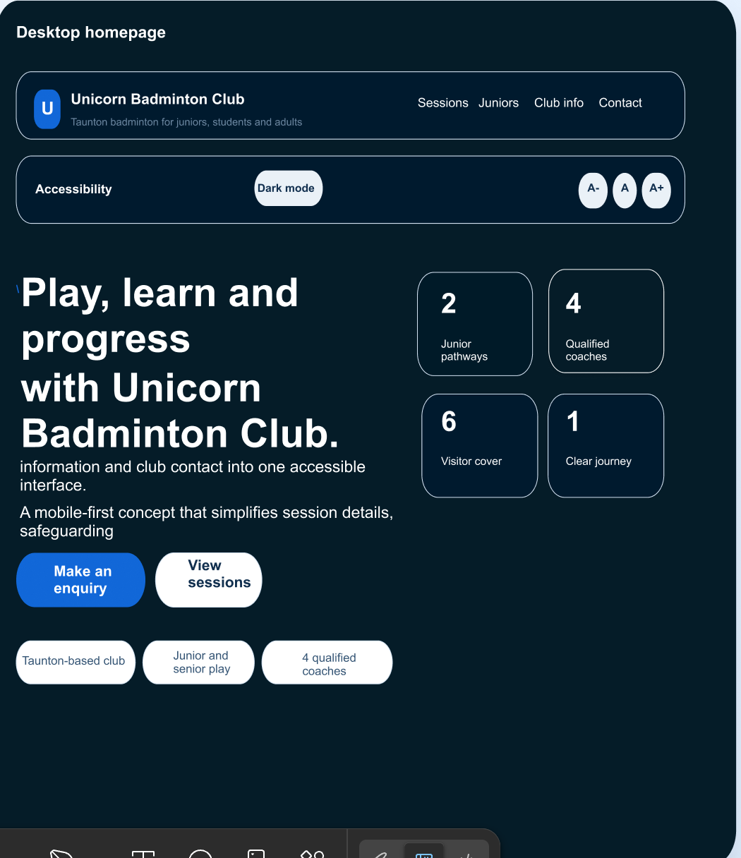
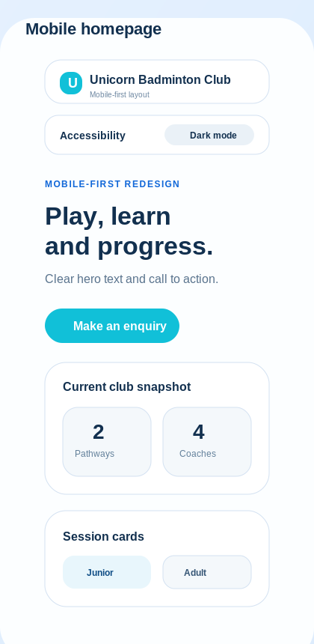
Figure 2. Mobile homepage concept board
The hero area combines a clear call to action with a summary card containing quick club facts. The sections that follow present sessions, the junior pathway, club information, weather, FAQs and contact details in a logical sequence. Accessibility was treated as part of the interface rather than an optional add-on, so the page includes a skip link, visible focus states, dark mode, font-size controls and persistent display preferences.

3. Version control / reposetory
Git was selected as the version control system because it provides a practical way to record development stages, recover earlier versions and document why design decisions changed. This is useful even on a small front-end project because interface work often improves through repeated refinement rather than one perfect first draft. The repository was organised around index.html, styles.css, script.js and a small assets folder.
The local repository shows an appropriate sequence of setup, styling, interaction, hierarchy improvement and final polish. A private GitHub repository could then be created and the local project pushed to it before granting access to the tutor account named in the brief. That final remote hosting step is an account-level action, but the local repository demonstrates the intended development workflow clearly.

4. Testing
Testing was divided into functionality, usability, accessibility and performance, because the brief explicitly asks for the website to be fully tested and compared against competitor websites. The most important issue was whether common tasks can be completed quickly and reliably: finding junior session times, identifying the club offer, changing the display style, and generating an enquiry.
Category |  | Test case |  | Expected result |  |  | Outcome
Functional |  | Navigation links |  | Each navigation item takes the user to the correct section. |  |  | Pass
Functional |  | Session filters |  | Cards switch between all, junior and adult/mixed views. |  |  | Pass
Functional |  | Contact form |  | Required fields must be completed before the email enquiry is created. |  |  | Pass
Functional |  | Weather API |  | Live weather is shown when available; fallback text appears if unavailable. |  |  | Pass
Usability |  | Small-screen readability |  | No horizontal scrolling is required on the planned mobile layout. |  |  | Pass
Usability |  | Task visibility |  | Sessions and contact routes appear before secondary supporting information. |  |  | Pass
Accessibility |  | Theme and font controls |  | Users can change and retain viewing preferences across sessions. |  |  | Pass
Accessibility |  | Keyboard access |  | Links, buttons, FAQ items and form controls remain keyboard reachable. |  |  | Pass
Performance |  | Asset strategy |  | The site stays lightweight by avoiding framework overhead. |  |  | Pass
Performance |  | Maintainability |  | Simple file structure reduces future editing complexity. |  |  | Pass
Functional |  | Google Map API |  | Call API to add a mini map in my web |  | Fail  (I tried to deal with it…  Wasn’t acceptable)
 | Functional |  | Smooth FAQ |  | open FAQ when you click + smooth |  |  | Failed  when function happens open quickly and jump

Additional verification was completed by checking the JavaScript syntax with Node and by confirming the HTML contained the expected sections, buttons and links. Because this is a front-end coursework prototype rather than a deployed production service, these checks were combined with careful manual review of spacing, hierarchy, touch targets and content clarity.
Several small development issues were identified and resolved. First, the original homepage layout idea risked becoming too text-heavy on desktop, so the hero was simplified into text plus a compact summary card. Second, the accessibility controls initially felt hidden in the header, so they were moved into a dedicated toolbar below the navigation. Third, the weather feature was changed from a hard dependency into an optional enhancement with a fallback message so the page remains understandable even if the API call fails.

5. Evaluation and discussion
The completed solution meets the minimum brief requirements and improves the user journey by prioritising decision-making content. Instead of forcing visitors to search across several pages, the redesign makes the club offer understandable from one screen: the user can see that the club is based in Taunton, that junior and senior opportunities exist, that qualified coaching is available, and that there is a clear way to make contact. This creates a competitive advantage through clarity rather than through unnecessary complexity.
Criterion | Current Unicorn site | Proposed redesign | Yeovil BC | Chew Valley BC
Front-page clarity | Information is more dispersed across pages and long text blocks. | Key content is prioritised on one page. | Strong sessions and join information. | Strong content structure and booking links.
Accessibility tools | No obvious dark mode or font controls visible in retrieved content. | Dark mode, font controls and skip link included. | No equivalent controls visible in retrieved content. | No equivalent controls visible in retrieved content.
Interactivity | Mainly informational and document-based. | API widget, filter controls and enquiry form logic included. | Clear calls to join/contact. | Clear booking and policy access.
Contact journey | Email details exist but are not central to the page flow. | Visible contact block and enquiry form near the end. | Dedicated join/contact paths. | Dedicated contact and booking paths.
Visual style | Legacy image-heavy structure. | Modern card-based layout with stronger hierarchy. | Structured community-club layout. | Content-rich multi-section layout.
Compared with competitor sites such as Yeovil Badminton Club and Chew Valley Badminton Club, the redesign is particularly strong in accessibility and first-screen clarity. Yeovil presents joining and session information well, while Chew Valley has a wide, well-organised set of pages including booking links and safeguarding materials. The proposed Unicorn redesign differentiates itself by making accessibility controls explicit and by simplifying the homepage into a quicker route from arrival to enquiry.
The chosen tools were suitable for the project. HTML provides semantic structure and a reliable accessibility foundation. CSS handles the responsive layout, theme variables and visual hierarchy. JavaScript adds progressive enhancement through filtering, persisted preferences, API integration and form behaviour. This stack is appropriate because it keeps the project lightweight and maintainable, which is an important consideration for a community sports club.
Future work could strengthen the solution further. A proper back-end form handler would be better than relying on the user’s email application. Registration forms and safeguarding PDFs could be placed in a cleaner resources area with short summaries and direct download links. A small content management system could support session updates or event news. Finally, formal browser audits and real user testing with parents, juniors and adult members would provide stronger evidence for future iterations.

6. Appendices - annotated code listings
The following examples show how the final front-end implements accessibility preferences, API integration and enquiry handling. Only short extracts are included here because the full codebase is supplied separately in the website ZIP.
Appendix A. Persisting display preferences
function applyTheme(theme) {
root.dataset.theme = theme;
themeToggle.textContent = theme === 'dark' ? 'Light mode' : 'Dark mode';
localStorage.setItem(STORAGE_KEYS.theme, theme);
}
function applyFontSize(size) {
root.dataset.fontSize = size;
localStorage.setItem(STORAGE_KEYS.fontSize, size);
}
This code improves accessibility by allowing users to keep their preferred viewing mode across visits and make it exotic.
Appendix B. Weather API request
const controller = new AbortController();
const timeout = setTimeout(() => controller.abort(), 4000);
const response = await fetch(endpoint, { signal: controller.signal });
clearTimeout(timeout);
The API example demonstrates live data integration while keeping the request lightweight and adding a timeout for resilience.
Appendix C. Contact form validation
if (!name || !email || !message) {
feedback.textContent = 'Please complete your name, email and message before continuing.';
return;
}
window.location.href = `mailto:info@unicornbadminton.club?subject=${subject}&body=${body}`;
The form checks essential fields before producing a guided email enquiry, and send it directly

7. References
- Chew Valley Badminton Club (2026) Home page and club information. Available at: https://www.chewvalleybadmintonclub.org.uk/ (Accessed: 26 March 2026).
- Duckett, J. (2011) HTML and CSS: Design and Build Websites. Indianapolis: Wiley.
- Duckett, J. (2014) JavaScript and JQuery: Interactive Front-End Web Development. Indianapolis: Wiley.
- Git (2026) About version control. Available at: https://git-scm.com/book/ms/v2/Getting-Started-About-Version-Control (Accessed: 26 March 2026).
- Mozilla (2025a) prefers-color-scheme - CSS. Available at: https://developer.mozilla.org/en-US/docs/Web/CSS/Reference/At-rules/%40media/prefers-color-scheme (Accessed: 26 March 2026).
- Mozilla (2025b) Web Storage API. Available at: https://developer.mozilla.org/en-US/docs/Web/API/Web_Storage_API (Accessed: 26 March 2026).
- Mozilla (2026) Fetch API. Available at: https://developer.mozilla.org/en-US/docs/Web/API/Fetch_API (Accessed: 26 March 2026).
- Open-Meteo (2026) Weather Forecast API documentation. Available at: https://open-meteo.com/en/docs (Accessed: 26 March 2026).
- OpenAI (2026) ChatGPT. Available at: https://openai.com/chatgpt/ (Accessed: 26 March 2026).
- Somerset County Badminton (2026) Home page. Available at: https://somersetbadminton.co.uk/ (Accessed: 26 March 2026).
- Unicorn Badminton Club (2026a) Home page. Available at: https://www.unicornbadminton.club/ (Accessed: 26 March 2026).
- Unicorn Badminton Club (2026b) Juniors. Available at: https://www.unicornbadminton.club/juniors.html (Accessed: 26 March 2026).
- Unicorn Badminton Club (2026c) Useful Information. Available at: https://www.unicornbadminton.club/info.html (Accessed: 26 March 2026).
- W3C (2025a) Mobile Accessibility at W3C. Available at: https://www.w3.org/WAI/standards-guidelines/mobile/ (Accessed: 26 March 2026).
- W3C (2025b) Web Content Accessibility Guidelines (WCAG) 2.1. Available at: https://www.w3.org/TR/WCAG21/ (Accessed: 26 March 2026).
- Yeovil Badminton Club (2026) Home page. Available at: https://www.yeovilbadmintonclub.co.uk/ (Accessed: 26 March 2026).

